**DATE:** September 28, 2023

**FROM:** Lisa Elliott, Chase Ehlo

**SUBJECT:** Forecasting Fall Flow Reduction Scenarios’ Impacts on TDM in the following year

**BACKGROUND**

During August-October, Reclamation needs to reduce flows in the Sacramento River, to conserve carryover in Lake Shasta to support the Coldwater Pool. Given the timing of these fall flow reductions (August-October), there is concern that the reductions will result in the dewatering of Winter-run Chinook salmon redds. Every year some redds are laid in shallow water during higher flows, and reducing the flow has the potential to dewater the redds, causing population loss. Each year, CDFW and PSMFC monitor shallow Winter-run redds to predict anticipated dewatering flows and timing of fry emergence, at which point dewatering is no longer a concern. The Upper Sacramento Scheduling Team (USST) holds meetings (August-October) to assist with weighing trade-offs between dewatering of winter-run redds and other fish and operational needs. Reclamation and other USST members may propose alternative schedules for the reductions that balance the needs of winter-run redds against other considerations. One consideration that has received less attention to date is the impact of flow reductions on the Temperature Dependent Mortality (TDM) of winter-run chinook salmon in the following year. To evaluate this consideration, a team used existing relationships between carryover and TDM to identify thresholds of carryover needed to reduce the chance of TDM. If the water cost of flow reductions does not exceed this threshold, then TDM will likely be unaffected by the flow reduction alternatives.

**DEMONSTRATION ANALYSIS SUMMARY**

Based on analyses of TDM that were included in the 2019 BiOp and preliminary analyses of TDM conducted as part of the LTO reinitiation of consultation process, we determined thresholds where we see a substantial decrease in the 95th percentile and/or outliers of TDM using the Martin model. An important caveat of using these prior analyses to set the thresholds is that the analyses used CalSim II, 2019 BiOp operations, and are missing the last 20 years of hydrology and meteorology data.

We determined that a threshold of 1,600 TAF of Shasta carryover, assuming 54°F is maintained above Clear Creek (Fig. 1), based on a substantial decrease in the 95th percentile of TDM using the Martin model and a second threshold of 2,200 TAF of carryover based on a substantial decrease in outliers. If carryover is forecasted to be above the 1,600 TAF threshold, differences in fall flow reductions will be anticipated to have little impact on TDM and we can have additional confidence that fall flow reductions will not affect TDM if carryover is above 2,200 TAF, assuming that operations are targeting 54°F is maintained above Clear Creek. In such instances, the TDM in the following year will be driven by fill rather than by differences in carryover. However, when carryover is below 1,600 TAF, we would anticipate an increased likelihood of adverse impacts due to poor refill. In such instances, differences in the fall flow reduction alternatives could have important implications for TDM in the following year.

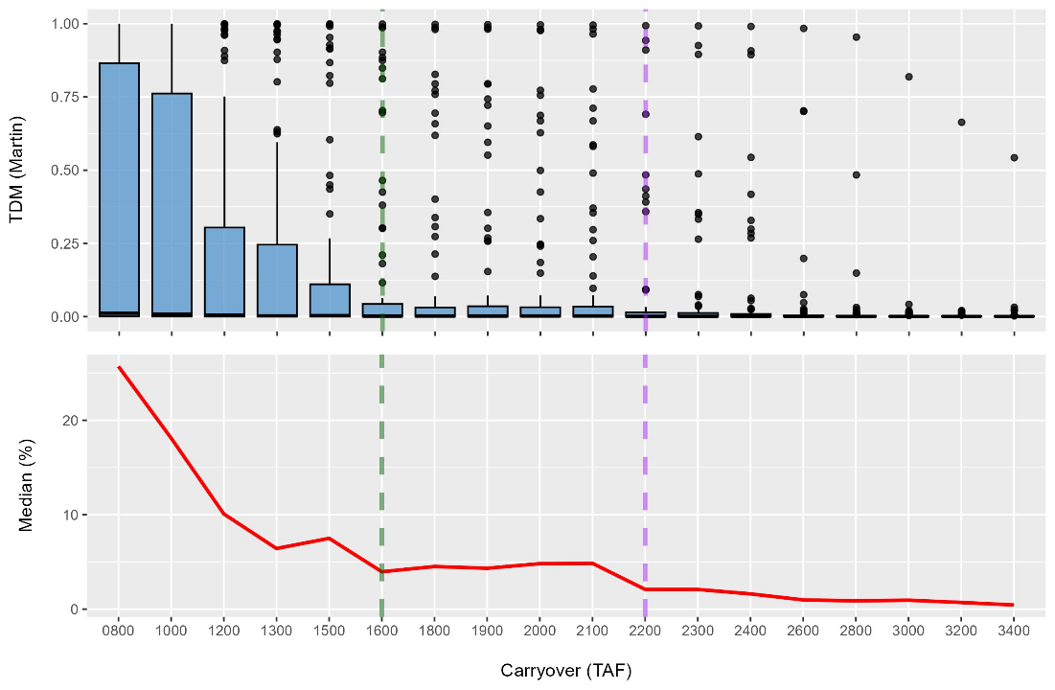

***Figure 1.*** *The dependence of TDM on the previous water year end of September storage in Shasta Reservoir. TDM is calculated using a 54 °F temperature target at Clear Creek as a position analysis, combinatorically analyzing starting storage, hydrology, and meteorology. This figure is intended for demonstration purposes only as it utilizes the Calsim II model with deprecated No Action Alternative operations logic. Dashed green line shows the threshold value where we see a substantial decrease in the 95th percentile of TDM using the Martin model. Dashed purple line shows threshold value where we see a substantial decrease in outliers with the Martin model.*

In addition, we propose 2,200 TAF as an appropriate threshold to consider if we are conforming to the 2019 BiOp operations for temperature management (Fig. 2), based on the substantial decrease in the 95th percentile of TDM using the Martin model.

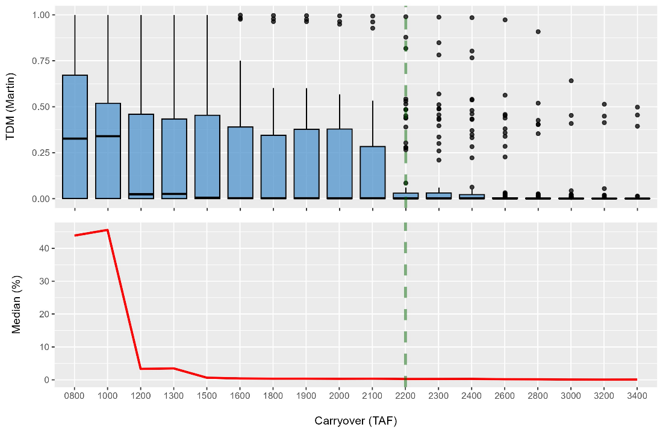

***Figure 2.*** *The dependence of TDM on the previous water year end of September storage in Shasta Reservoir. TDM is calculated using the 2019 BiOp temperature target at Clear Creek as a position analysis, combinatorically analyzing starting storage, hydrology, and meteorology. This figure is intended for demonstration purposes only as it utilizes the Calsim II model with deprecated No Action Alternative operations logic. Dashed green line shows the carryover value where we see a substantial decrease in the 95th percentile of TDM using the Martin model.*

To determine if carryover meets the proposed thresholds, we can use the September 90% Exceedance forecast to identify the anticipated carryover (End of September Shasta storage). We consider this the reference operation scenario and can then subtract the combined September total volume from this reference carryover to determine the reduction in carryover for each flow alternative. If a fall flow reduction alternative takes the carryover below the threshold, we can then flag the alternative for the USST.

**DEMONSTRATION RESULTS**

The September 90% Exceedance Forecast calls for a carryover of 3,485 TAF. Total September Volume of the proposed fall flow reduction alternatives ranges from 387 TAF to 532 TAF, which means that the resulting carryover will be ≥2,953 TAF and will therefore be above the proposed thresholds, under either 54°F or the 2019 BiOp temperatures. Given this, we can expect that TDM is not an important consideration for comparing the proposed fall flow reduction alternatives in 2023.

**DISCUSSION**

The differences between the proposed fall flow reduction alternatives are usually only 100-200 TAF, and therefore it will be rare that this small difference will significantly change the carryover to influence TDM, except in very dry years. In addition, TDM is less responsive to Shasta carryover (End of September storage) than to fill (End of April storage; Fig. 3), as indicated by the broader curve and slower slope of the median (%) in Figure 3, as compared to Figures 1 and 2. In most years, the fill will be able to compensate for the small differences in carryover expected between fall flow reduction alternatives. The major exception will be in cases of the third year of a drought.

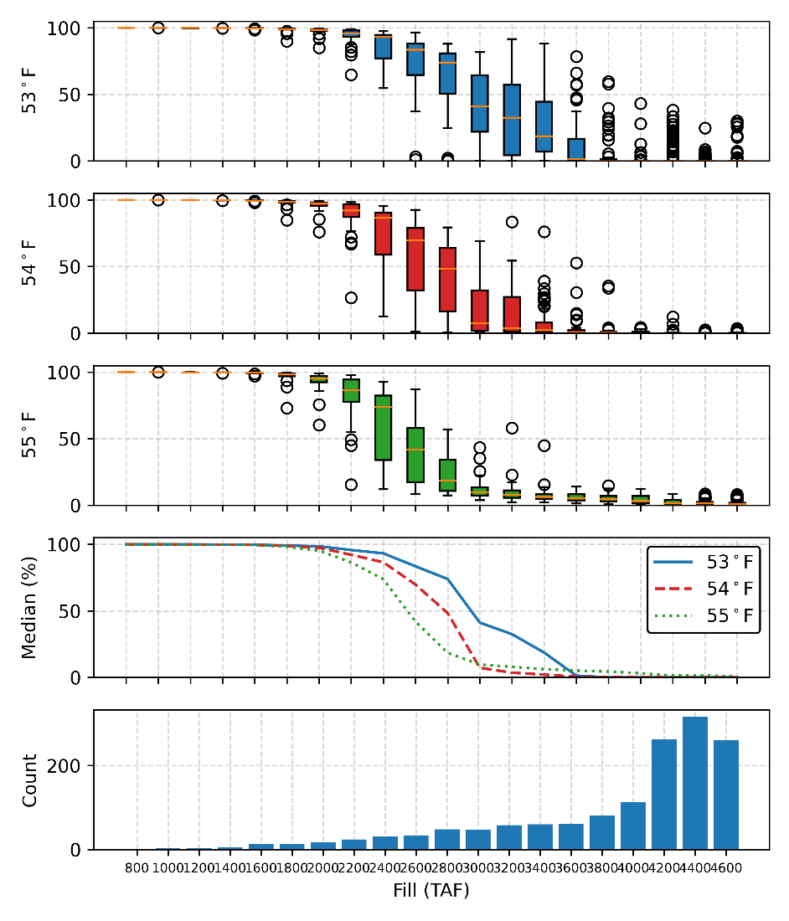

***Figure 3.*** *The dependence of TDM on the current water year end of April storage in Shasta Reservoir. TDM is calculated using a 54° F temperature target at Clear Creek as a position analysis, combinatorically analyzing starting storage, hydrology, and meteorology. This figure is intended for demonstration purposes only as it utilizes the Calsim II model with deprecated No Action Alternative operations logic.*

**POTENTIAL NEXT STEPS**

The above analysis could be improved upon using CalSim 3 and updated operations with the most recent 20 years of hydrology and meteorology. A positional analysis conducted by the Modeling Division would potentially be an improvement on this approach.